 Bank Marketing Dataset

CIND-820 Final Result and report

Table of Contents

Abstract 3

Introduction 3

Data Analysis 5

Data exploration and importing. 5

Checking the Categorical Data. 7

The relation between categorical feature and labels. 9

Checking the Numerical Data. 10

Relation between continuous feature and target data. 11

Find the outliers in numerical features. 12

Explore the correlation between these numerical features. 13

Feature dropping. 14

Scale Numerical Value. 14

Encode the categorical Values. 15

Modeling. 16

Random forest output. 16

Logistic Regression output. 17

KNN output. 17

Decision Tree output. 4

Results 18

Annexes 19

Reference. 19

The Code. 20

The Output file. 27

# Abstract

What Is Marketing? Marketing refers to activities a company undertakes to promote the buying or selling of a product or service. Marketing includes advertising, selling, and delivering products to consumers or other businesses. Some marketing is done by affiliates on behalf of a company.

There are many ways of the marketing and one of them is the phone marketing.

Banks depends on the phone marketing to attract the existing customer for their new products or services.

The data is related with direct marketing campaigns (phone calls) of a Portuguese banking institution. The classification goal is to predict if the client will subscribe a term deposit (variable y).

# Introduction

Bank, an institution that deals in money and its substitutes and provides other money-related services.

This financial institute depends on depositing money from customers with interest rate and lending the money to other customers with higher rate.

So, the bank to be able to complete this cycle and be able to lend money invest this money in other business and generate revenues and be profitable. they should be able to grab more customers with term deposit to be able do so.

Gaining more customers require many marketing campaigns to reach this target The marketing have many ways:

1. Ads, TV, sign boards, radio, etc.
2. Digital Marketing.
3. Telemarketing.

Many banks believe that the telemarketing beside to the Bank reputation have an major effect to grab new and existing customers to the services since the agent can on spot answer all the customers inquiries and can hear from the customers about their concerns and solve them immediately or raise it to the higher management which could increase the customer satisfaction and trust in the bank and have a long term deposit.

To reach this goal banks should have accurate data base about their customers through something call Know Your Customer (KYC) and asking to update it every two years and some banks asking to do it on yearly basis.

Even some banks they are going beyond that and will freeze the account if the customer didn’t update his data.

Since the banks have the data, the banks will start to reach their customers and convince them to register in one of their term deposits.

The banks could reach to information can be useful to predict the customer behavior and try to contact the customer with higher percentage of acceptance to register in this program and improve the success rate and improve the operating cost.

Many banks now start using the machine learning and data science to have good results and reach to their target by creating a mathematical model and contact the customer with high probability to be part of their marketing campaign.

This model will tell the agent that this customer has a high possibility to join our program and the agent will sort them with high probability and contact them as high priority and keep the with low probability at the end of the list.

By this the bank will achieve many targets:

1. Increase the number of term of deposits.
2. Improve the revenue streams by secure the cash for long term investments.
3. Improve the agent’s utilizations and target.
4. Reduce the cost in many aspects, HR cost, phone, costs, space, etc.

The Portuguese banking institution believes that the marketing campaign are giving the required results and attracting more customers in their term deposits so he wants to make a model for their customers so the successful phone rate increased by predicting if the customer will subscribe or not.

Here will be using the UCI machine learning data for Bank Marketing Analysis.

Data are available in:

<http://archive.ics.uci.edu/ml/machine-learning-databases/00222/>



In summary the data structure is:

|  |  |  |  |
| --- | --- | --- | --- |
| **Data Set Characteristics:** | Multivariate | **Number of Instances:** | 45211 |
| **Attribute Characteristics:** | Real | **Number of Attributes:** | 17 |
| **Associated Tasks:** | Classification | **Missing Values?** | N/A |

# Data Analysis

## Data exploration and importing.

As a first step, to be able to review and studying we need to review the data and use one of the main data tools which will be Python.

Will be reading the data from the csv file, below screen shot will show the importing steps and the results out of that:

After importing, the attributes should be checked and known:

The data input variables are from 0 – 16 with:

|  |  |  |  |  |
| --- | --- | --- | --- | --- |
| RangeIndex: 45211 entries, 0 to 45210  Data columns (total 17 columns): | | | | |
| # | Column | Count | Non-Null | Dtype |
| 0 | age | 45211 | non-null | int64 |
| 1 | job | 45211 | non-null | object |
| 2 | marital | 45211 | non-null | object |
| 3 | education | 45211 | non-null | object |
| 4 | default | 45211 | non-null | object |
| 5 | balance | 45211 | non-null | int64 |
| 6 | housing | 45211 | non-null | object |
| 7 | loan | 45211 | non-null | object |
| 8 | contact | 45211 | non-null | object |
| 9 | day | 45211 | non-null | int64 |
| 10 | month | 45211 | non-null | object |
| 11 | duration | 45211 | non-null | int64 |
| 12 | campaign | 45211 | non-null | int64 |
| 13 | pdays | 45211 | non-null | int64 |
| 14 | previous | 45211 | non-null | int64 |
| 15 | poutcome | 45211 | non-null | object |
| 16 | y | 45211 | non-null | object |

The attributes here are mixed between integers and objects.

Missing data is a fatal point in the predictions, so we must check if there is any missing info or not. The command is: df.isnull().sum().

The output of the command shows no missing data:

|  |  |
| --- | --- |
| **age 0** | **day 0** |
| **job 0** | **month 0** |
| **marital 0** | **duration 0** |
| **education 0** | **campaign 0** |
| **default 0** | **pdays 0** |
| **balance 0** | **previous 0** |
| **housing 0** | **poutcome 0** |
| **loan 0** | **y 0** |
| **contact 0** |  |

**dtype: int64**

Also, the data can be described:

|  |  |  |  |  |  |  |
| --- | --- | --- | --- | --- | --- | --- |
| age | balance | day | duration | campaign | pdays | previous |
| count | 45211 | 45211 | 45211 | 45211 | 45211 | 45211 |
| mean | 40.93621 | 1362.272 | 15.80642 | 258.1631 | 2.763841 | 40.19783 |
| std | 10.61876 | 3044.766 | 8.322476 | 257.5278 | 3.098021 | 100.1287 |
| min | 18 | -8019 | 1 | 0 | 1 | -1 |
| 25% | 33 | 72 | 8 | 103 | 1 | -1 |
| 50% | 39 | 448 | 16 | 180 | 2 | -1 |
| 75% | 48 | 1428 | 21 | 319 | 3 | -1 |
| max | 95 | 102127 | 31 | 4918 | 63 | 871 |

## Checking the Categorical Data.

First, we must check the target data output to see if the data are balanced or not:

**no 0.88**

**yes 0.12**

**Name: y, dtype: float64**

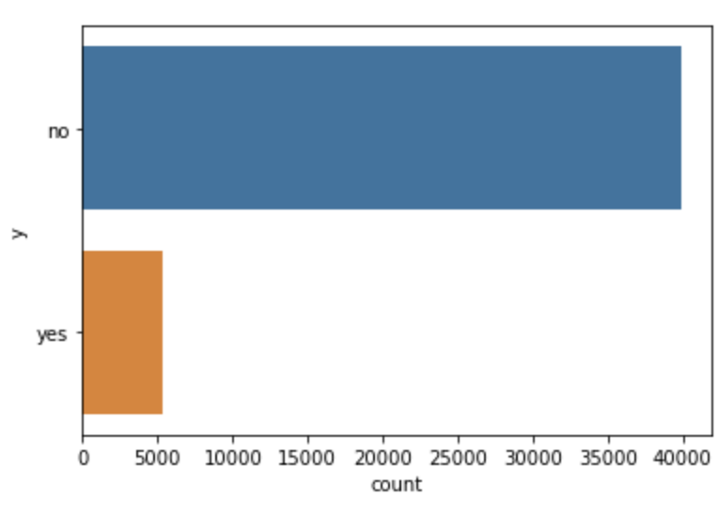

Our data showing that the target output is imbalanced.

This will make our prediction biased on **NO.**

We have 10 categorical data and they are:

* The feature is **job** and the number of categories are 12.
* The feature is **marital** and the number of categories are 3.
* The feature is **education** and the number of categories are 4.
* The feature is **default** and the number of categories are 2.
* The feature is **housing** and the number of categories are 2.
* The feature is **loan** and the number of categories are 2.
* The feature is **contact** and the number of categories are 3.
* The feature is **month** and the number of categories are 12.
* The feature is **poutcome** and the number of categories are 4.
* The feature is **y** and the number of categories are 2.

Now we must study the data for the categorical data with respect to the target data ‘y’.

And check the distribution for each feature.

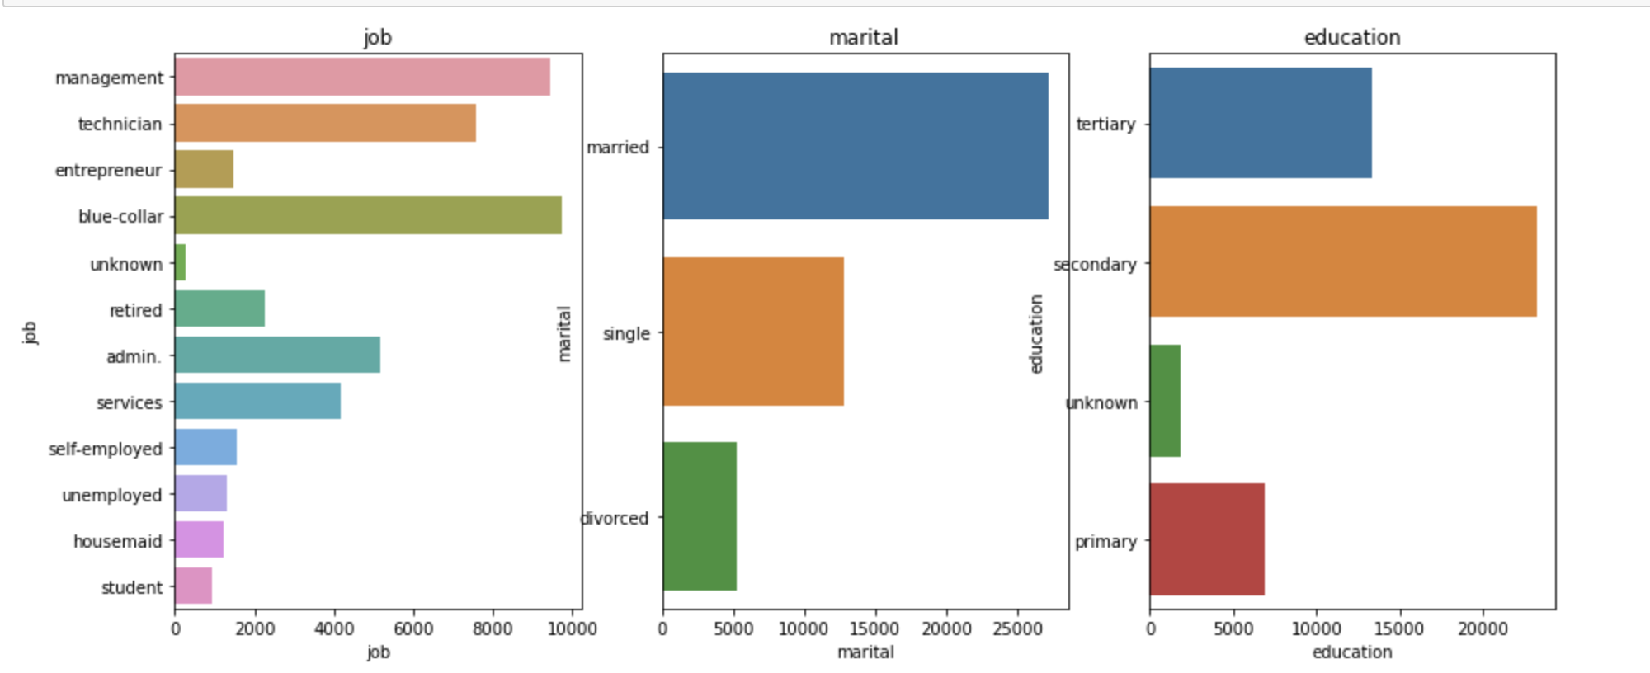

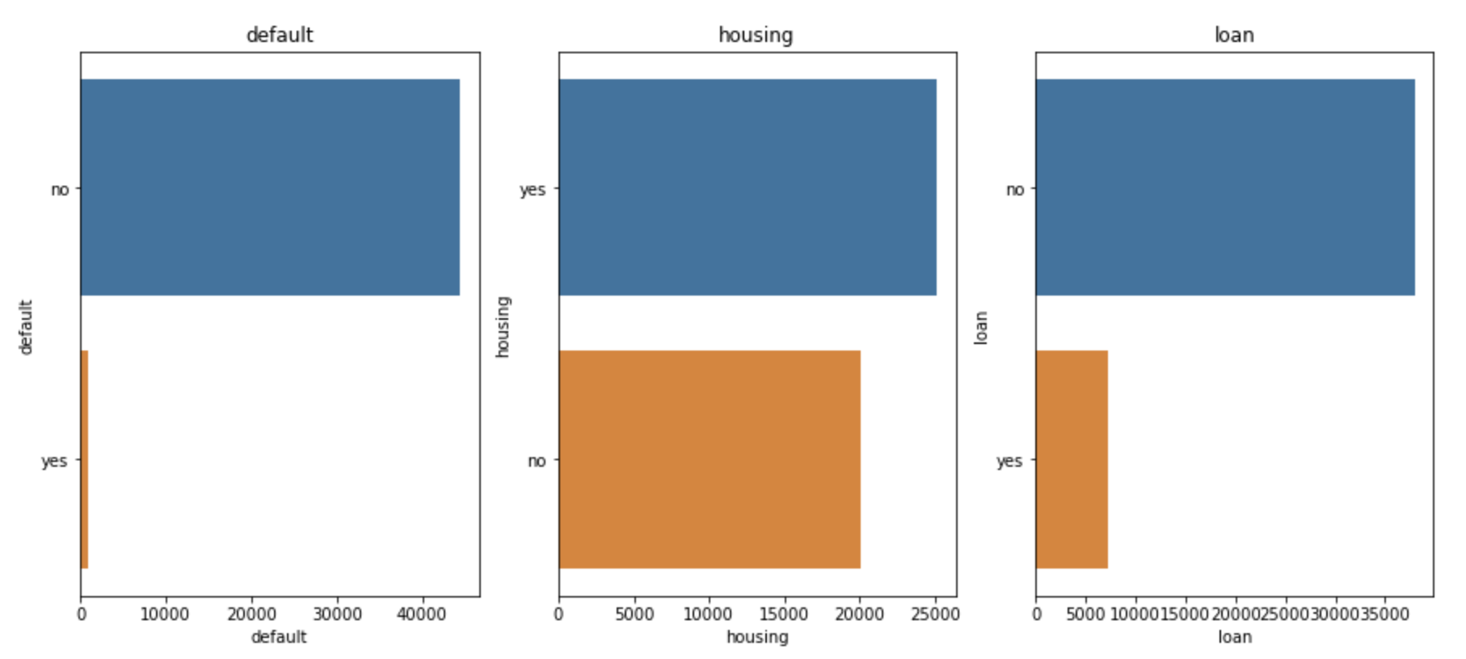

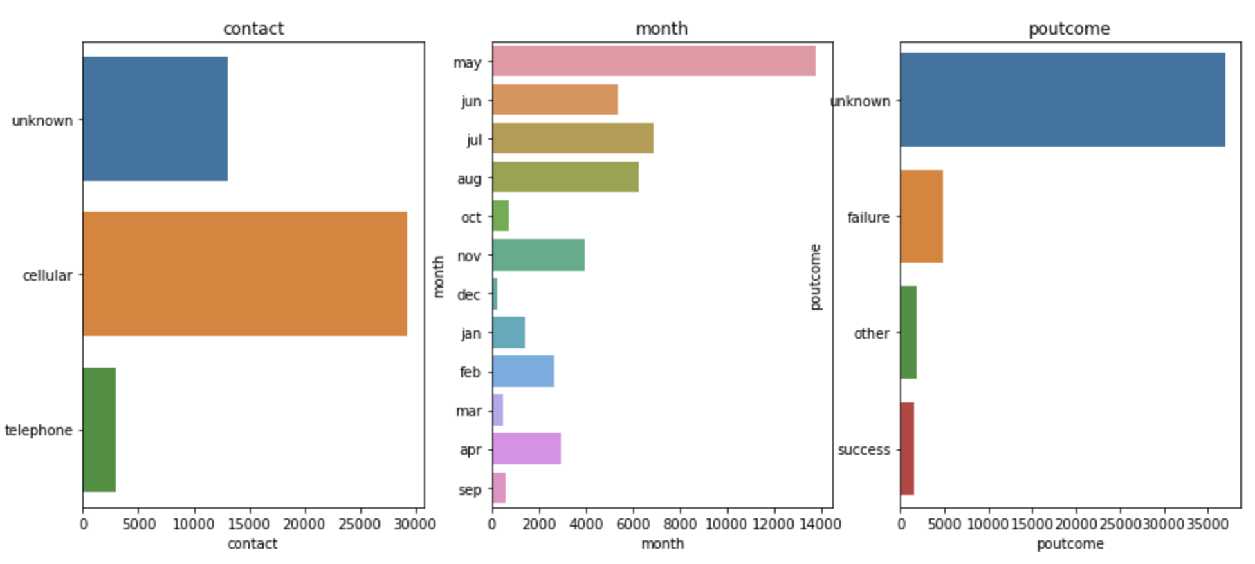

## The relation between categorical feature and labels.

1. Check the target label split over the categorical features.
2. Find the relation with them.
   * 1. Even customers with No Default Majority of the time are refusing.
     2. Candidate with Housing loan, most of the time are refusing.
     3. Married, secondary, tertiary, and single are with High NO.

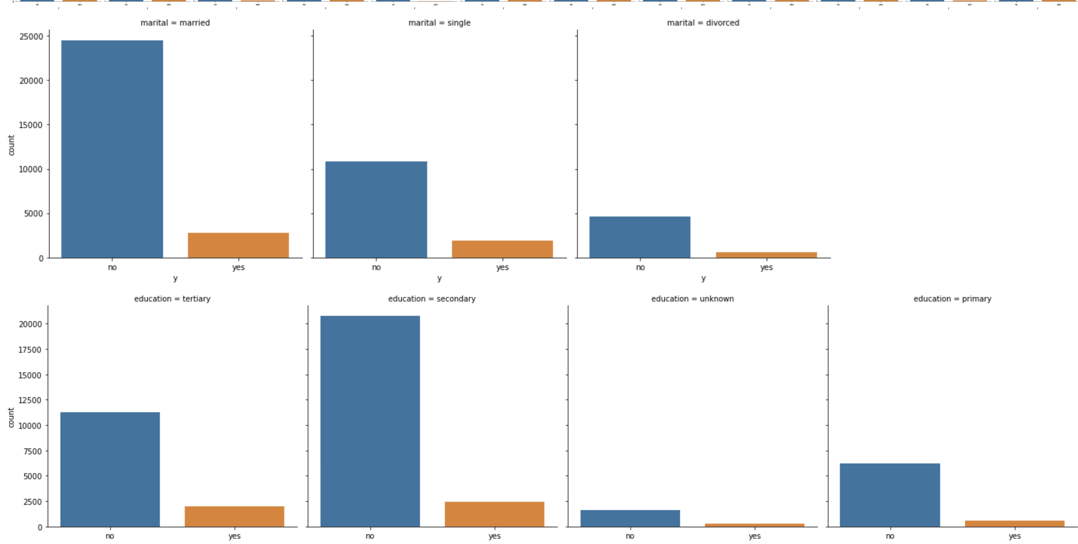 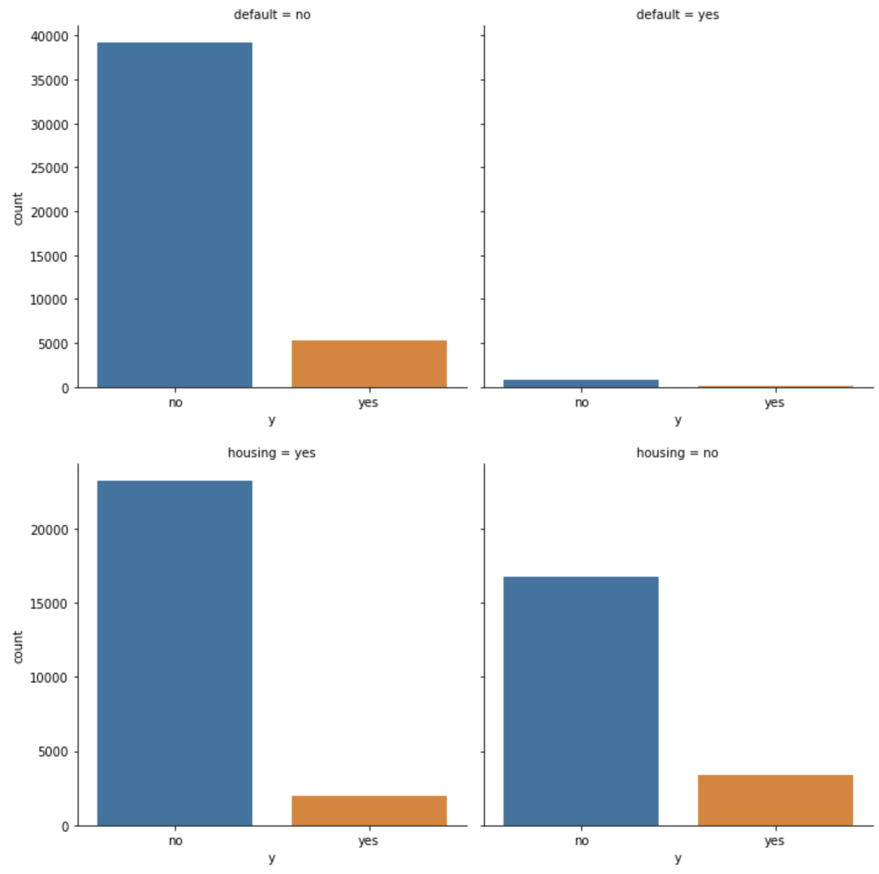

## Checking the Numerical Data.

After searching and checking the Numerical attributes, we found 7 attributes are available and they are:

|  |  |  |  |  |  |  |
| --- | --- | --- | --- | --- | --- | --- |
| **age** | **balance** | **day** | **duration** | **campaign** | **pdays** | **previous** |

Also,

* + They are not discrete.
  + They are continuous data.

Now we need to check the distribution for them:

|  |  |
| --- | --- |
|  |  |
|  | |

We note that the majority are left skew. From the above paragraph, we found some outliers.

### Relation between continuous feature and target data.

From previous chart we can notice some outliers so do check that we plot the boxplot to see the outliers.

### Find the outliers in numerical features.

Many points are outliers which may affect the model if we compare them with the target data ‘y’.

In the next figure we can find the outliers for most of the data, except day.

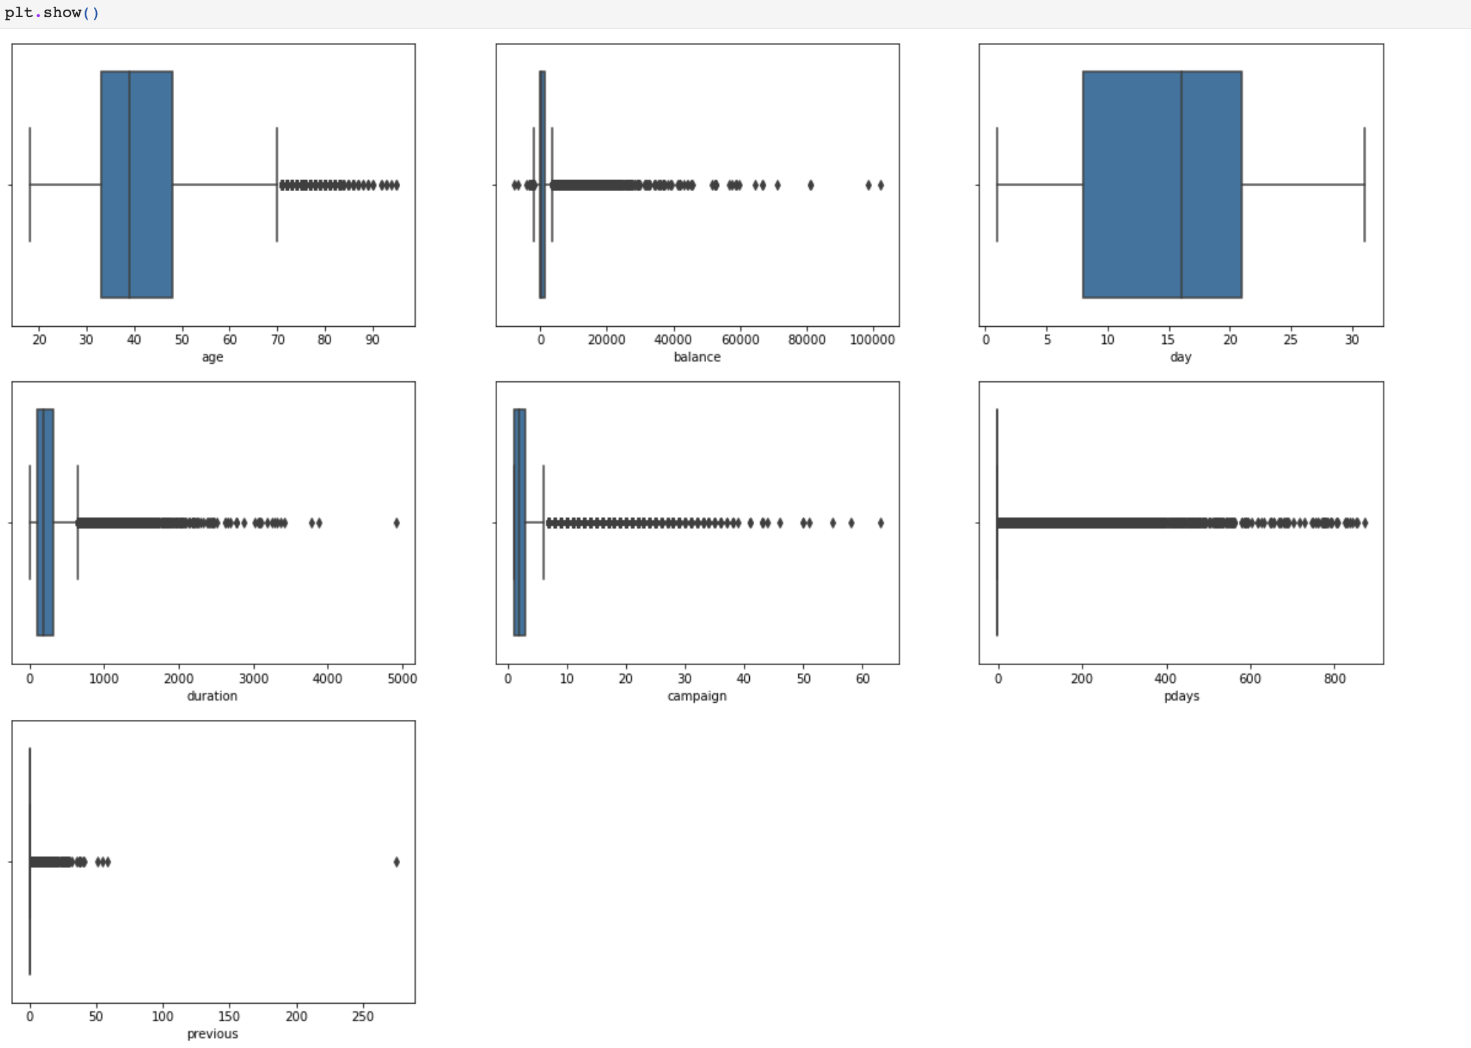

### Explore the correlation between these numerical features.

From the heat map we can note that almost zero correlation magnitude for the numerical fact except for the Previous and pdays, they have low positive correlation 0.45.

## Feature dropping.

Studying the features based on the above charts we can conclude:

* Drop the default feature since **they are highly imbalance.**

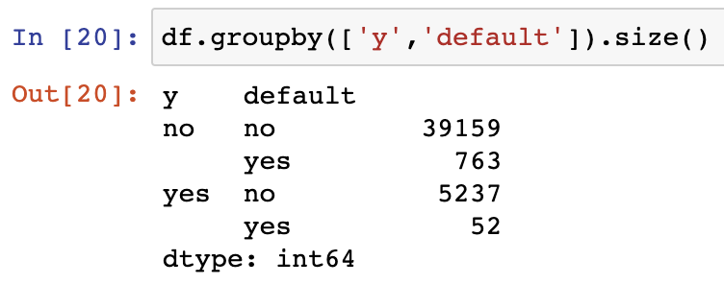

* Age, Balance, duration, campaign, pdays and day will be kept.

## Scale Numerical Value.

Numerical data should be scaled.

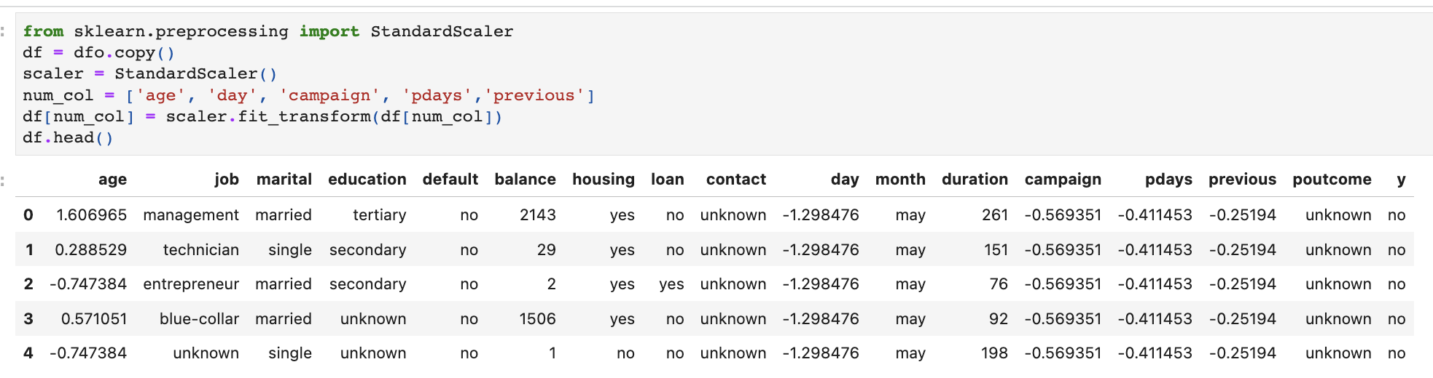

|  |  |  |  |  |  |  |  |  |  |  |  |  |  |  |  |  |  |
| --- | --- | --- | --- | --- | --- | --- | --- | --- | --- | --- | --- | --- | --- | --- | --- | --- | --- |
|  | age | job | marital | education | default | balance | housing | loan | contact | day | month | duration | campaign | pdays | previous | poutcome | y |
| 0 | 1.606965 | management | married | tertiary | no | 2143 | yes | no | unknown | -1.298476 | may | 261 | -0.569351 | -0.411453 | -0.25194 | unknown | no |
| 1 | 0.288529 | technician | single | secondary | no | 29 | yes | no | unknown | -1.298476 | may | 151 | -0.569351 | -0.411453 | -0.25194 | unknown | no |
| 2 | -0.747384 | entrepreneur | married | secondary | no | 2 | yes | yes | unknown | -1.298476 | may | 76 | -0.569351 | -0.411453 | -0.25194 | unknown | no |
| 3 | 0.571051 | blue-collar | married | unknown | no | 1506 | yes | no | unknown | -1.298476 | may | 92 | -0.569351 | -0.411453 | -0.25194 | unknown | no |
| 4 | -0.747384 | unknown | single | unknown | no | 1 | no | no | unknown | -1.298476 | may | 198 | -0.569351 | -0.411453 | -0.25194 | unknown | no |

## Encode the categorical Values.

Using the hot coding in python to transfer the categorical data to numbers to be able used in the model for predictions and predict the target data.

|  |  |  |  |  |  |  |  |  |  |  |  |  |  |  |  |  |  |  |  |  |  |
| --- | --- | --- | --- | --- | --- | --- | --- | --- | --- | --- | --- | --- | --- | --- | --- | --- | --- | --- | --- | --- | --- |
|  | job_admin. | job_blue-collar | job_entrepreneur | job_housemaid | job_management | job_retired | job_self-employed | job_services | job_student | job_technician | ... | poutcome_success | poutcome_unknown | age | balance | day | duration | campaign | pdays | previous | y |
| 0 | 0 | 0 | 0 | 0 | 1 | 0 | 0 | 0 | 0 | 0 | ... | 0 | 1 | 58 | 2143 | 5 | 261 | 1 | -1 | 0 | 0 |
| 1 | 0 | 0 | 0 | 0 | 0 | 0 | 0 | 0 | 0 | 1 | ... | 0 | 1 | 44 | 29 | 5 | 151 | 1 | -1 | 0 | 0 |
| 2 | 0 | 0 | 1 | 0 | 0 | 0 | 0 | 0 | 0 | 0 | ... | 0 | 1 | 33 | 2 | 5 | 76 | 1 | -1 | 0 | 0 |
| 3 | 0 | 1 | 0 | 0 | 0 | 0 | 0 | 0 | 0 | 0 | ... | 0 | 1 | 47 | 1506 | 5 | 92 | 1 | -1 | 0 | 0 |
| 4 | 0 | 0 | 0 | 0 | 0 | 0 | 0 | 0 | 0 | 0 | ... | 0 | 1 | 33 | 1 | 5 | 198 | 1 | -1 | 0 | 0 |

## Modeling.

* First, we must split the data into training and testing.

The Ratio it will be 80% Training 20% Testing.

* In the prediction modeling will be using 4 models:
  + Random Forest.
  + Logistic Regression.
  + K-Nearest Neighbors (KNN).
  + Decision Tree.

The score for each model is:

|  |  |  |  |  |
| --- | --- | --- | --- | --- |
|  | Random | Logistic Reg | KNN | Decision |
| Score | 90.82 | 89.91 | 89.62 | 88.13 |

### Random forest output.

|  |  |  |  |  |
| --- | --- | --- | --- | --- |
|  | precision | recall | f1-score | support |
| 0 | 0.93 | 0.97 | 0.95 | 7993 |
| 1 | 0.66 | 0.43 | 0.52 | 1050 |
| accuracy |  |  | 0.91 | 9043 |
| Macro Avg | 0.8 | 0.7 | 0.73 | 9043 |
| Weighted Avg | 0.9 | 0.91 | 0.9 | 9043 |

|  |  |  |
| --- | --- | --- |
|  |  | |
| Confusion Matrix for Random Forest is: | 7764 | 229 |
| 601 | 449 |

### 

### Logistic Regression output.

|  |  |  |  |  |
| --- | --- | --- | --- | --- |
|  | precision | recall | f1-score | support |
| 0 | 0.91 | 0.98 | 0.94 | 7993 |
| 1 | 0.64 | 0.3 | 0.41 | 1050 |
| accuracy |  |  | 0.90 | 9043 |
| Macro Avg | 0.78 | 0.64 | 0.68 | 9043 |
| Weighted Avg | 0.88 | 0.90 | 0.88 | 9043 |

|  |  |  |
| --- | --- | --- |
|  |  | |
| Confusion Matrix for Logistic Regresion is: | 7820 | 173 |
| 739 | 311 |

### KNN output.

|  |  |  |  |  |
| --- | --- | --- | --- | --- |
|  | precision | recall | f1-score | support |
| 0 | 0.91 | 0.98 | 0.94 | 7993 |
| 1 | 0.63 | 0.25 | 0.36 | 1050 |
| accuracy |  |  | 0.90 | 9043 |
| Macro Avg | 0.77 | 0.62 | 0.65 | 9043 |
| Weighted Avg | 0.88 | 0.90 | 0.88 | 9043 |

|  |  |  |
| --- | --- | --- |
|  |  | |
| Confusion Matrix for KNN is: | 7838 | 155 |
| 784 | 266 |

### Decision Tree output.

|  |  |  |  |  |
| --- | --- | --- | --- | --- |
|  | precision | recall | f1-score | support |
| 0 | 0.94 | 0.93 | 0.93 | 7993 |
| 1 | 0.49 | 0.52 | 0.50 | 1050 |
| accuracy |  |  | 0.88 | 9043 |
| Macro Avg | 0.71 | 0.72 | 0.72 | 9043 |
| Weighted Avg | 0.88 | 0.88 | 0.88 | 9043 |

|  |  |  |
| --- | --- | --- |
|  |  | |
| Confusion Matrix for Decision Tree is: | 7431 | 562 |
| 511 | 539 |

# 

# Results

The random forest is the best score, and it has 90.82% compared to the others but KNN has the highest Positive prediction in the confusion matrix with 7838 correct predictions compared to 7764 for the RF.

Based on that we can consider our KNN model the best model to be used.

KNN output:

|  |  |
| --- | --- |
|  | KNN |
| Score | 89.62 |

|  |  |  |  |  |
| --- | --- | --- | --- | --- |
|  | precision | recall | f1-score | support |
| 0 | 0.91 | 0.98 | 0.94 | 7993 |
| 1 | 0.63 | 0.25 | 0.36 | 1050 |
| accuracy |  |  | 0.90 | 9043 |
| Macro Avg | 0.77 | 0.62 | 0.65 | 9043 |
| Weighted Avg | 0.88 | 0.90 | 0.88 | 9043 |

|  |  |  |
| --- | --- | --- |
|  |  | |
| Confusion Matrix for KNN is: | 7838 | 155 |
| 784 | 266 |

# Annexes

## References.

* Moro, S., Cortez, P., & Rita, P. (2014). A Data-Driven Approach to Predict the Success of Bank Telemarketing. Decision Support Systems, 62, 22-31.  
  <https://doi.org/10.1016/j.dss.2014.03.001>
* Bank Marketing Data Classification Using Machine Learning Dr. Smitha Shekar B1 , Pooja A2 Associate Professor, Department of CS&E, Dr.A.I.T, Bengaluru, India1 M.Tech Student, Department of CS&E, Dr.A.I.T, Bengaluru, India2
* Tuba Parlar1 , Songul Kakilli Acaravci2 * 1 Vocational School of Antakya, Department of Computer Technology, Mustafa Kemal University, Antakya, Hatay, Turkey, 2 Faculty of Economics and Administrative Sciences, Department of Finance and Accounting, Mustafa Kemal University, Hatay, Turkey.
* <https://github.com/np788/bankmarketing/blob/master/Bank_Marketing_Project.ipynb>.
* <https://medium.com/swlh/using-machine-learning-to-predict-subscription-to-bank-term-deposits-for-clients-with-python-aec8a4690807>.
* <https://www.youtube.com/watch?v=z8VE71abh_k>.
* <https://rstudio-pubs-static.s3.amazonaws.com/793938_04e78c2ce4d04878b722f5e001f9ff90.html>.
* https://www.kaggle.com/datasets/janiobachmann/bank-marketing-dataset.

## The Code.

import pandas as pd

import matplotlib.pyplot as plt

import seaborn as sns

get_ipython().run_line_magic('matplotlib', 'inline')

from sklearn.model_selection import train_test_split

import warnings

warnings.filterwarnings("ignore")

# In[ ]:

dfo = pd.read_csv("bank-full.csv",";")

df = dfo.copy()

df.head()

# In[ ]:

df.isnull().sum()

# In[ ]:

df.describe()

# In[ ]:

df.columns

# In[ ]:

df.shape

# In[ ]:

df.info()

# In[ ]:

print(round(df.y.value_counts(normalize=True),2))

sns.countplot(y = 'y',data = df)

# In[ ]:

for col in df.select_dtypes(include = 'object').columns:

print(col)

print(df[col].unique())

# In[ ]:

cat_feat = [feature for feature in df.columns if df[feature].dtypes =='O']

for feature in cat_feat:

print("The feature is {} and the number of categories are {}".format(feature, len(df[feature].unique())))

# In[ ]:

plt.figure(figsize=(15,88),facecolor='white')

plotnumber = 1

for categorical_feature in cat_feat:

ax = plt.subplot(12,3,plotnumber)

sns.countplot(y = categorical_feature,data = df)

plt.xlabel(categorical_feature)

plt.title(categorical_feature)

plotnumber+=1

plt.show()

# In[ ]:

for categorical_feature in cat_feat:

sns.catplot(x = 'y',col = categorical_feature,kind = 'count', data = df)

plt.show()

# In[ ]:

num_feat = [feature for feature in df.columns if df[feature].dtypes !='O']

print("Number of Numerical Variable is: ",len(num_feat) )

df[num_feat].head()

# In[ ]:

disc_feat = [feature for feature in num_feat if len(df[feature].unique()) <25]

print("Number of Discrete Variable is:", len(disc_feat))

# In[ ]:

cont_feat = [feature for feature in num_feat if feature not in disc_feat+['y']]

print("Number of Continuous Variable is:", len(cont_feat))

# In[ ]:

for features in num_feat:

df2 = df.copy()

df2[features].hist(bins=25)

plt.xlabel(features)

plt.ylabel('Count')

plt.title(features)

plt.show()

# In[ ]:

plt.figure(figsize=(20,60),facecolor='white')

plotnumber = 1

for cont_f in cont_feat:

ax = plt.subplot(12,3,plotnumber)

sns.boxplot(x='y',y=df[cont_f],data = df)

plt.xlabel(cont_f)

plotnumber+=1

plt.show()

# In[ ]:

plt.figure(figsize=(20,60),facecolor='white')

plotnumber = 1

for num_f in num_feat:

ax = plt.subplot(12,3,plotnumber)

sns.boxplot(df[num_f])

plt.xlabel(num_f)

plotnumber+=1

plt.show()

# In[ ]:

cor_mat = df.corr()

fig=plt.figure(figsize=(15,9))

sns.heatmap(cor_mat,annot = True)

# In[ ]:

df.groupby(['y','default']).size()

# In[ ]:

df.drop(['default'],axis = 1, inplace = True)

# In[ ]:

df.groupby(['y','pdays']).size()

# In[ ]:

df.drop(['pdays'],axis = 1,inplace = True)

# In[ ]:

df.groupby(['age'],sort=True)['age'].count()

# In[ ]:

df.groupby(['y','balance'],sort=True)['balance'].count()

# In[ ]:

df.groupby(['y','duration'],sort=True)['duration'].count()

df1 = df[df['duration'] < 5/60]

df1.groupby(['y','duration'],sort=True)['duration'].count()

# In[ ]:

df['duration'] = df['duration'].apply(lambda n:n/60).round(2)

# In[ ]:

df.groupby(['y','campaign'],sort=True)['campaign'].count()

# In[ ]:

df1 = df[df['campaign']<33]

# In[ ]:

df1.groupby(['y','campaign'],sort=True)['campaign'].count()

# In[ ]:

df1 = df[df['previous']<31]

# In[ ]:

from sklearn.preprocessing import StandardScaler

df = dfo.copy()

scaler = StandardScaler()

num_col = ['age', 'day', 'campaign', 'pdays','previous']

df[num_col] = scaler.fit_transform(df[num_col])

df.head()

# In[ ]:

from sklearn.preprocessing import OneHotEncoder

encoder = OneHotEncoder(sparse = False)

cat_col = ['job', 'marital', 'education', 'default', 'housing','loan', 'contact', 'month', 'poutcome']

df = dfo.copy()

df_encoded = pd.DataFrame(encoder.fit_transform(df[cat_col]))

df_encoded.columns = encoder.get_feature_names(cat_col)

df = df.drop(cat_col,axis =1)

df = pd.concat([df_encoded,df],axis =1)

df['y'] = df['y'].apply(lambda x: 1 if x=='yes' else 0)

print("Shape of Data frame is:", df.shape)

df.head()

# In[ ]:

X = df.drop(['y'],axis =1)

y = df['y']

from sklearn.model_selection import train_test_split

X_train,X_test,y_train,y_test = train_test_split(X,y,shuffle=True,test_size=.2,random_state=1)

# In[ ]:

cols = X_train.columns

from sklearn.preprocessing import RobustScaler

scaler = RobustScaler()

X_train = scaler.fit_transform(X_train)

X_test = scaler.fit_transform(X_test)

X_train = pd.DataFrame(X_train, columns = [cols])

X_test = pd.DataFrame(X_test, columns = [cols])

# In[ ]:

from sklearn.ensemble import RandomForestClassifier

rfc = RandomForestClassifier(n_estimators=100,random_state=0)

rfc.fit(X_train, y_train)

R_pred = rfc.predict(X_test)

# In[ ]:

from sklearn.metrics import accuracy_score, classification_report,confusion_matrix

R_score = accuracy_score(y_test,R_pred)

R_cm = confusion_matrix(y_test,R_pred)

print("Random Model Score is:",(R_score.round(4))*100)

print(classification_report(y_test,R_pred))

print("Confusion Matrix for Random Forest is:",'\n', R_cm)

# In[ ]:

from sklearn.linear_model import LogisticRegression

LG_model = LogisticRegression()

Fun_LG = LG_model.fit(X_train,y_train)

L_pred = LG_model.predict(X_test)

# In[ ]:

L_score = accuracy_score(y_test,L_pred)

L_cm = confusion_matrix(y_test,L_pred)

print("Logistic Model Score is:",(L_score.round(4))*100)

print(classification_report(y_test,L_pred))

print("Confusion Matrix for Logistic Regression is:",'\n', L_cm)

# In[ ]:

from sklearn.neighbors import KNeighborsClassifier

knn = KNeighborsClassifier(n_neighbors = 20)

K_model= knn.fit(X_train, y_train)

K_pred = K_model.predict(X_test)

# In[ ]:

K_score = accuracy_score(y_test,K_pred)

K_cm = confusion_matrix(y_test,K_pred)

print("KNN Score is:",(K_score.round(4))*100)

print(classification_report(y_test,K_pred))

print("Confusion Matrix for KNN is:",'\n', K_cm)

# In[ ]:

from sklearn.tree import DecisionTreeClassifier

clf = DecisionTreeClassifier()

DTree = clf.fit(X_train,y_train)

D_pred = DTree.predict(X_test)

# In[ ]:

D_score = accuracy_score(y_test,D_pred)

D_cm = confusion_matrix(y_test,D_pred)

print("Decision Tree Score is:",(D_score.round(4))*100)

print(classification_report(y_test,D_pred))

print("Confusion Matrix for Decision Tree is:",'\n', D_cm)

## The Output file.

